PRACTICAL NO. 1

Encryption Algorithm
- Substitution technique

- Caeser Cipher:
Code:
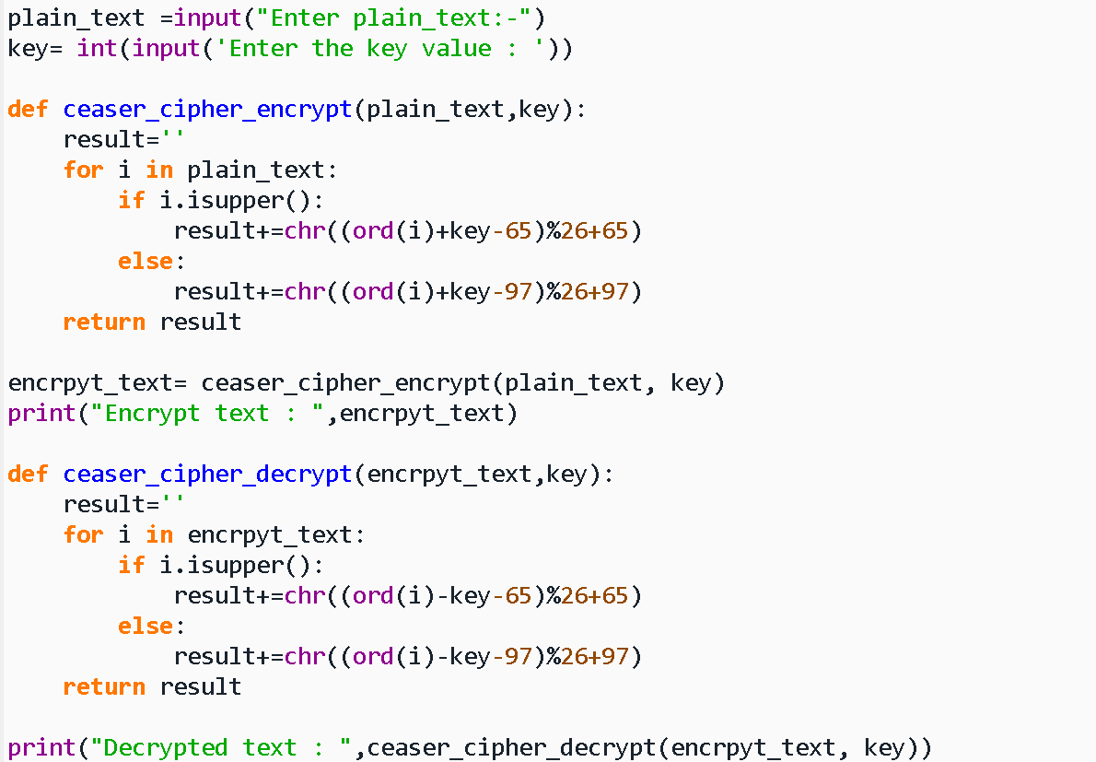
Output:

- Monoalphabetic Cipher:
Code:
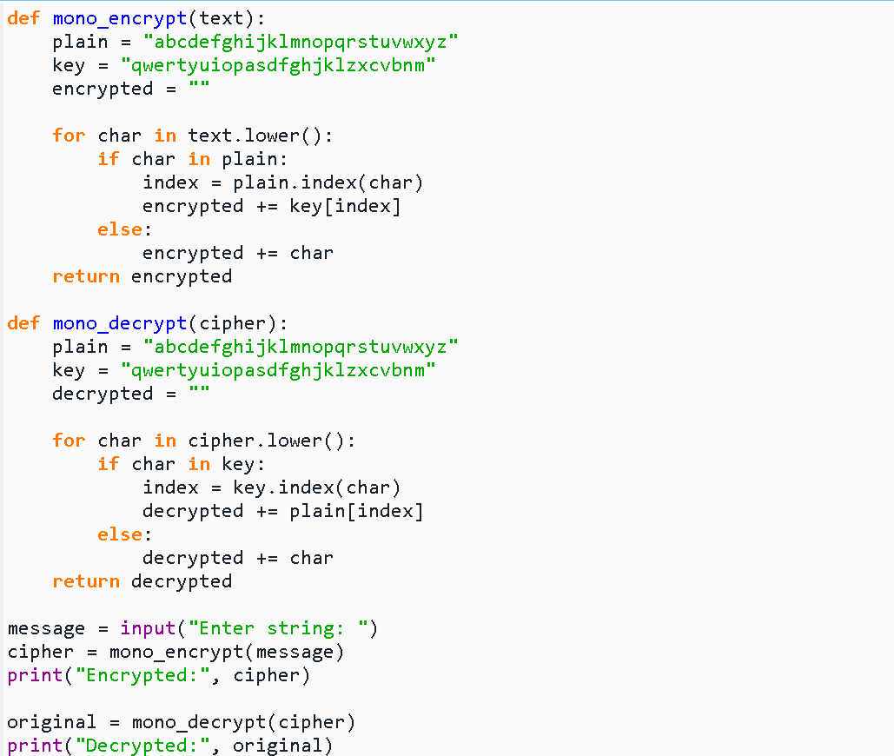
Output:
- Multiplicative Cipher:
Code:
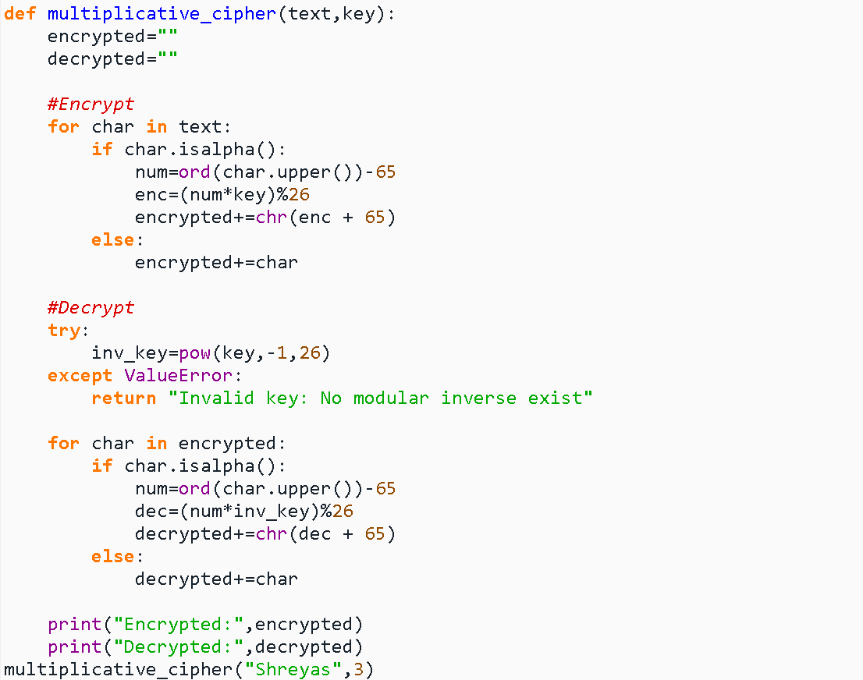
Output:
- Polyalphabetic Cipher:
Code:
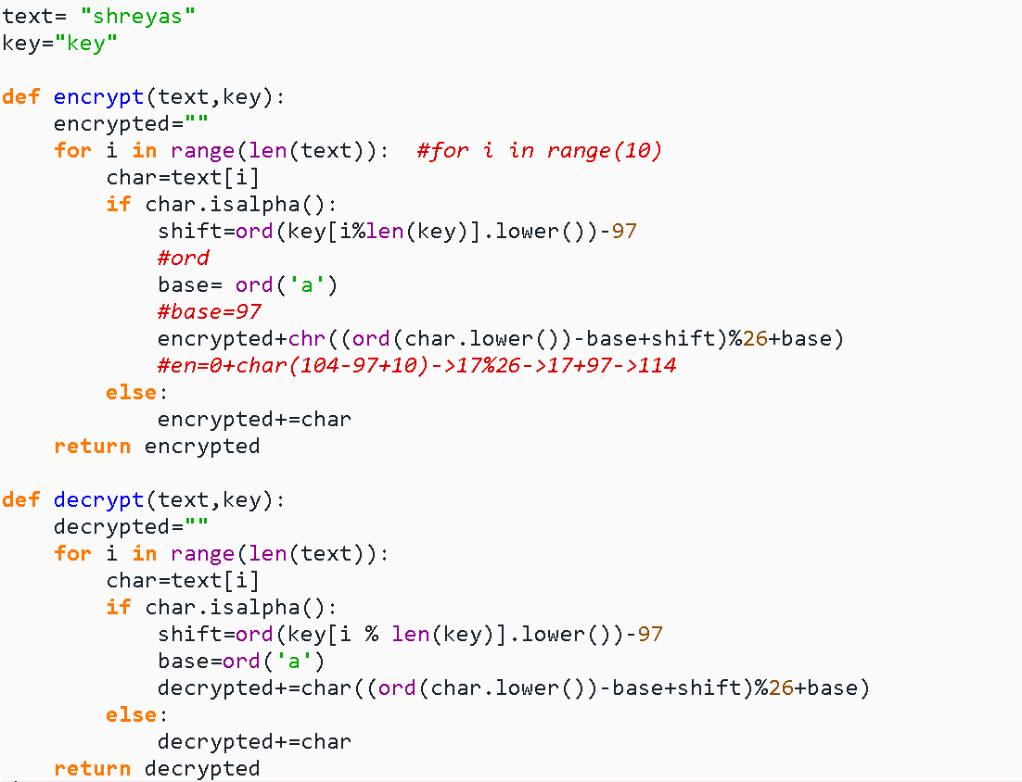
Output:
- Transposition technique

- Rail-Fence Cipher:
Code:
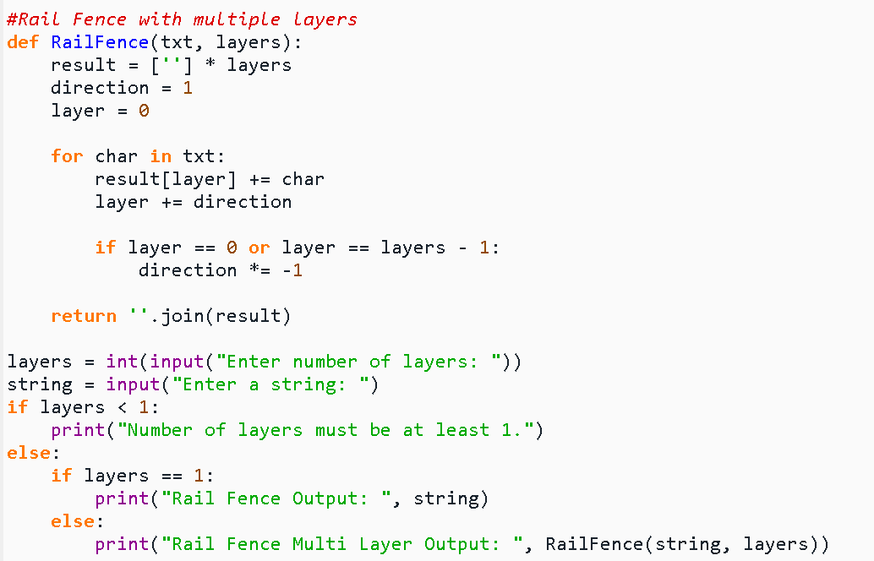
Output:
- Vernam Cipher:
Code:
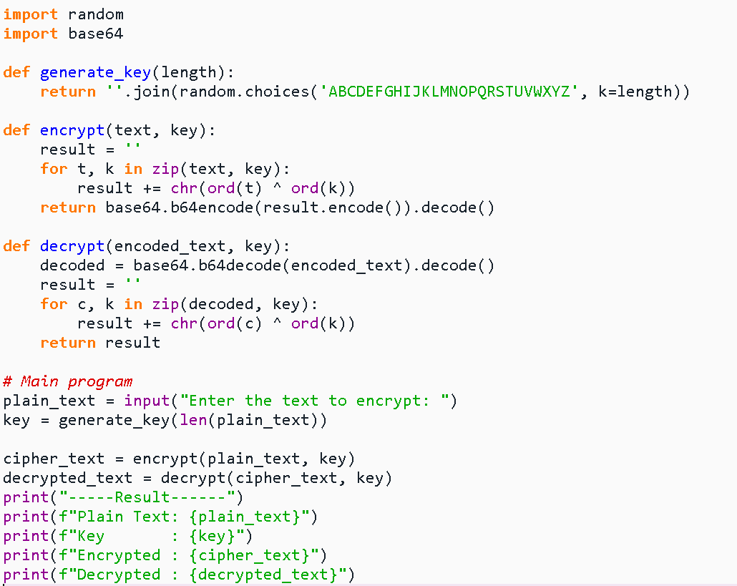
Output:
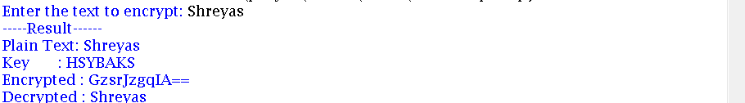
- Combine Code
Code:
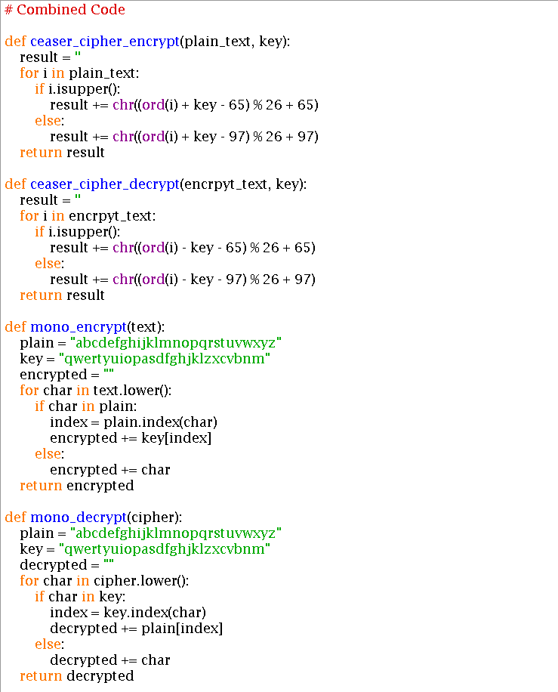
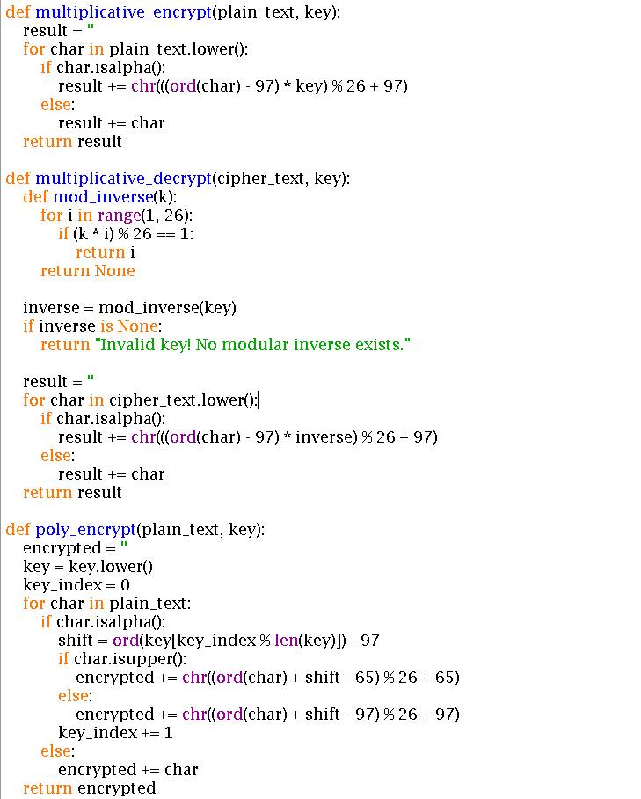
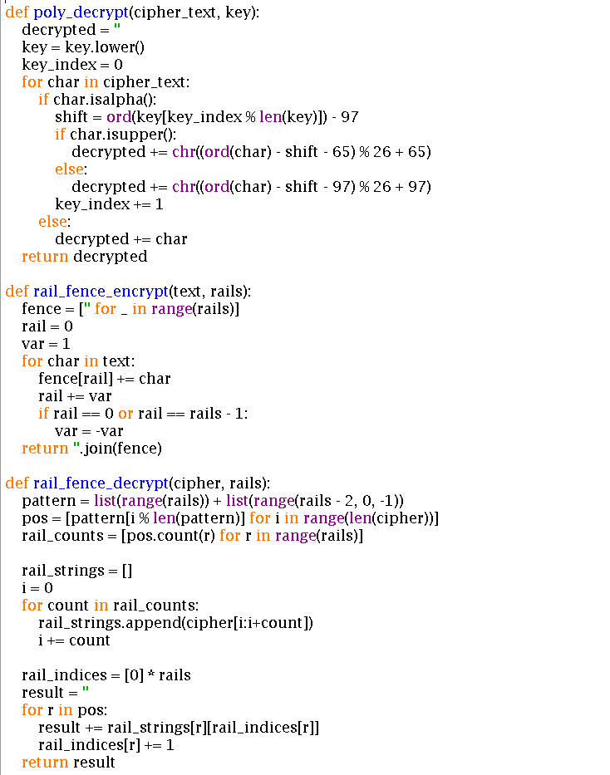
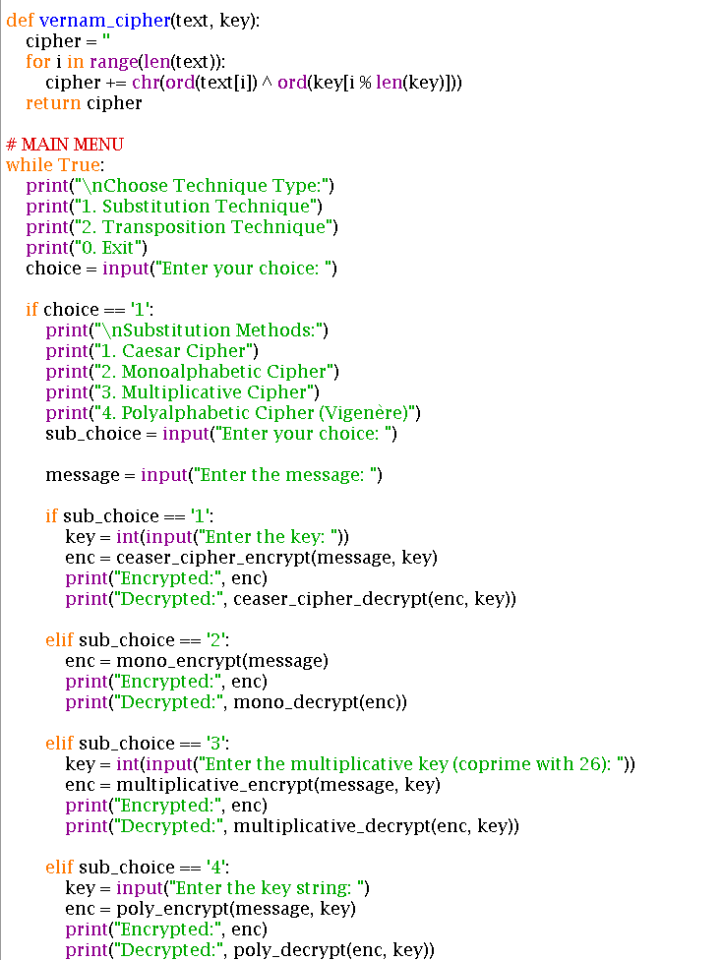

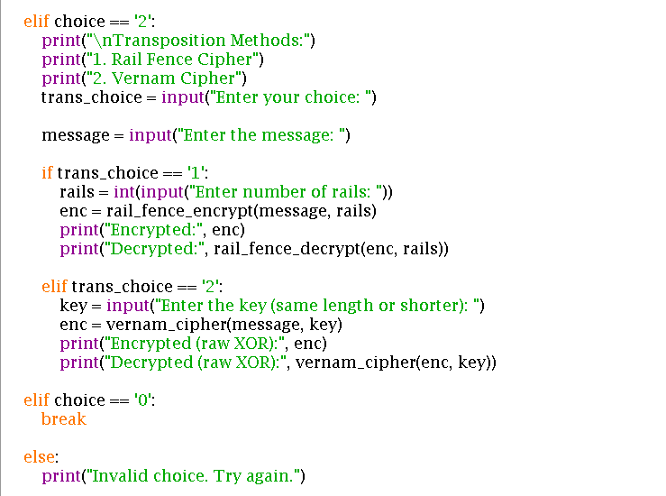
Output:
